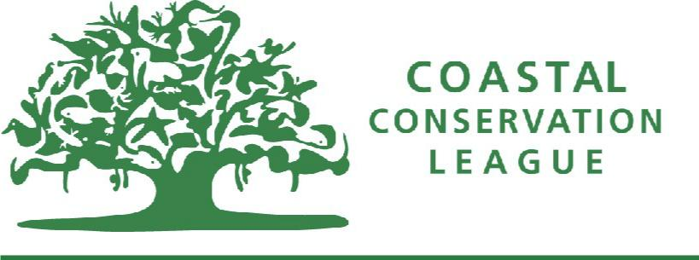

PLASTIC POLLUTION IN SOUTH CAROLINA

Abundance
- The Ocean Conservancy organizes an annual international beach sweep each September. In 2017, volunteers collected 520,900 plastic grocery bags, making single use plastic bags the fifth most collected item worldwide after cigarette butts, plastic bottles, plastic bottle caps, and food wrappers.
- Charleston Waterkeeper estimates that the total volunteer time spent participating in regular trash sweeps and clean-ups they organized in 2017 was worth $100,000 based on our state’s average hourly wage.
- Prior to Folly Beach’s plastic bag ban, Charleston Surfrider picked up 131 bags. After the ordinance was passed, this number dropped to 28. On average, Folly now has 7 bags collected during sweeps. Cities with no ordinance have much more plastic bag litter on average: Mount Pleasant: 38, Sullivan’s Island: 69, and Charleston: 178.

Marine Impact
- Worldwide, plastic bag pollution harms more than 700 species of marine life. In February 2017, a beaked whale was found beached with 30 plastic bags in its stomach – an all-too-common reality.
- Sea turtles often mistake plastic bags for jellyfish, a favorite food source for turtles. Bags block turtles’ stomachs and often cause them to starve. The South Carolina Aquarium’s sea turtle hospital has treated 20 turtles for plastic ingestion. In one case, a single turtle had eaten at least 12 pieces of plastic bag material. Over half of the post-hatchling turtles in a recent study were also found to have already ingested plastics.
- In sunlight and seawater, plastic bags quickly break down into pieces of plastic less than five millimeters in size, known as microplastics. Microplastics never fully decompose. They act as sponges for chemicals and toxins in the environment like DDT and PCB. As plastics break down, toxins are continuously absorbed and released. Fish, mussels, shrimp, oysters and even zooplankton eat microplastics. These eventually work their way up the food chain all the way to us. That’s right – we are consuming microplastics too.

Use and Disposal
- On average, a plastic bag is used for 12 minutes and between only 1 – 5% of all plastic bags are recycled. The remaining bags make their way into our waterways and turn into microplastics or sit in a landfill for upwards of 500 years.
- Plastic bags clog storm drains, causing flooding and stagnant water – perfect mosquito breeding habitat.
- Horry County Solid Waste Authority estimates that it costs $100,000 annually to repair garbage sorting machines that are damaged by plastic bags. Plastic bags also damage municipal recycling equipment and because of this, Charleston County cannot accept them.

Coastal Conservation League
P.O. Box 1765 • Charleston, S.C. 29402-1765
Telephone (843) 723-8035

